Welcome to our first virtual scavenger hunt at the Greene County Public Library!
Children in 6th grade and older are invited to complete the tasks listed in our hunt. Tasks* are meant to show off how silly, fun, creative, and thoughtful you can be. The more you submit, the more chances you get to win. Bonus points will be given for excellent photos and photo quality. Simply read the task, make it happen using your heart and your smarts, and take the picture(s).
Send your submissions via email to greenelibrarysubmissions@gmail.com. Three winners will be chosen to receive a GCPL swag bag and be featured on the library website. Woohoo!!
*some items taken from https://www.gish.com/ (a scavenger hunt event)
RULES
- Participants must be 6th grade and up
- You can enter as many times as you want (more submissions means more chances at winning)
- Submissions must be a photo or photo collage (look at the item for more information)
- Photos should look nice (backgrounds, lighting, etc.)
- All submissions should be emailed to: greenelibrarysubmissions@gmail.com
- Follow the sample below of the celebrity Skittle pie art and provide your name, item number, description, and submission (if you’d rather us contact you by phone, include that as well)
- If you don’t want to be on the library site, but you want to participate and send in a photo, let us know
- Submissions are due by August 1st!
- Start immediately!

Submission Sample:
Julie Gannon (your name)
Item #3 – celebrity Skittle pie art
Photo (or attach file)
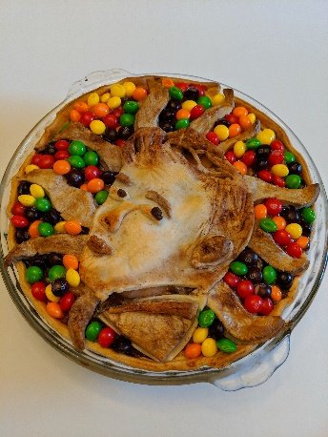

- Photo Collage: Wake up! It's time to deliver the morning paper, on a bike, in your house, to a loved one in bed.
- Photo Collage: Have a person under 6 create a recipe with the foods in your kitchen. Help them by doing whatever they need and then eat it.
- Photo: Using your recyclables and garbage, create a piece of art of your favorite celebrity.
- Photo: Missed your spring dance? Get dressed to the nines and virtually dance with someone on a video call or Zoom.
- Photo: Christmas in July!! Put on your best, I mean ugliest, holiday sweater and give a gift to someone who has made a difference in your life. The gift can be homemade or store bought, but should be wrapped beautifully.
- Photo: Lego Challenge! Grownups always complain about stepping on Legos so make them some shoes out of Legos to make them more comfortable.
- Photo: Couch potato. Carve a lovely sofa sculpture from a potato.
- Photo: What’s a social distancing hug look like? Seriously, I need to know.
- Photo: Use your graphic design skills to create a photo from somewhere you wish you were. Put yourself there too! Photoshop okay!
- Photo: Display a roll of toilet paper like the treasure that it is.
- Photo: Normally, your pet is NEVER allowed to do this under ANY circumstances. But, of course, these are NOT normal times.
- Photo: Your new best friend is an object in your home. Take a page from Tom Hanks in Castaway, decorate your object (basketball, appliance, etc…) and have an interaction. It’s not weird at all.
- Photo: Write a moving handwashing haiku. Post it above your bathroom sink.
- Photo: Nap and make it a good one. No! Make it the best one!
- Side-by-side Photo: Re-create your favorite album cover using the items and people in your home.
- Side-by-side Photo: What's something you've always wished you could do, but never bothered to learn that your grandparent (or other person from that generation) knows how to do? Can your grandfather crochet? Can your Aunt Lorna bake bread? Have a Facetime (or similar) call with him or her and have them teach you this skill. Screengrab your conversation and the finished product in two side-by-side images.
- Photo: Thank essential workers with a message of art and appreciation towards them on your windows or your driveway.
- Photo: We LOVE our families, but occasionally we all need a little break. Right now, however, that can be challenging. Let's see your best quarantine technique for hiding from your relatives (camouflage, "mad-skills" hiding, appliance impersonation, invisibility... whatever it takes!)
- Photo: Use household items (books, boxes, kitchen utensils, anything...) to create one of the natural or man-made wonders of the world and take a selfie in front of it as if you're a tourist. You can use forced perspective.
- Photo: Straw hats are so last year. Show us the new hot trend: eco-friendly sun hats made from the weeds from your garden.
- Photo Collage: As long as we have technology, we can keep our distance AND be social. Deliver a no-touch cheerful message of support to a neighbor or friend using a drone. The note has to hang off the drone like a flag so they don't touch the drone. POV of the drone.
- Photo: Toilet paper is getting scarce, and so are a lot of animals on the planet. Create a sculpture of an endangered species from empty toilet-tissue tubes(s) and/or paper towel tubes.
- Side-by-side Photo: Here comes the airplane! Feed an adult some soup, pudding, or milky cereal using CDC-recommended distancing guidelines of at least 6 feet away - the longer the "spoon," the better. Take a picture of the feeding side-by-side with an after image.
- Photo: Make a set of jewelry or a crown from paperclips - one so ostentatious, it would make Queen Elizabeth blush. (You can adorn it with anything you have around the house as "jewels.")
- Photo: Be the change! What causes are you passionate about? Contact your local representative, make someone register to vote, start a petition, or find another way to make your voice heard. This one is pretty open-ended because we want to see what YOU can do.

