Tonyo

Mona

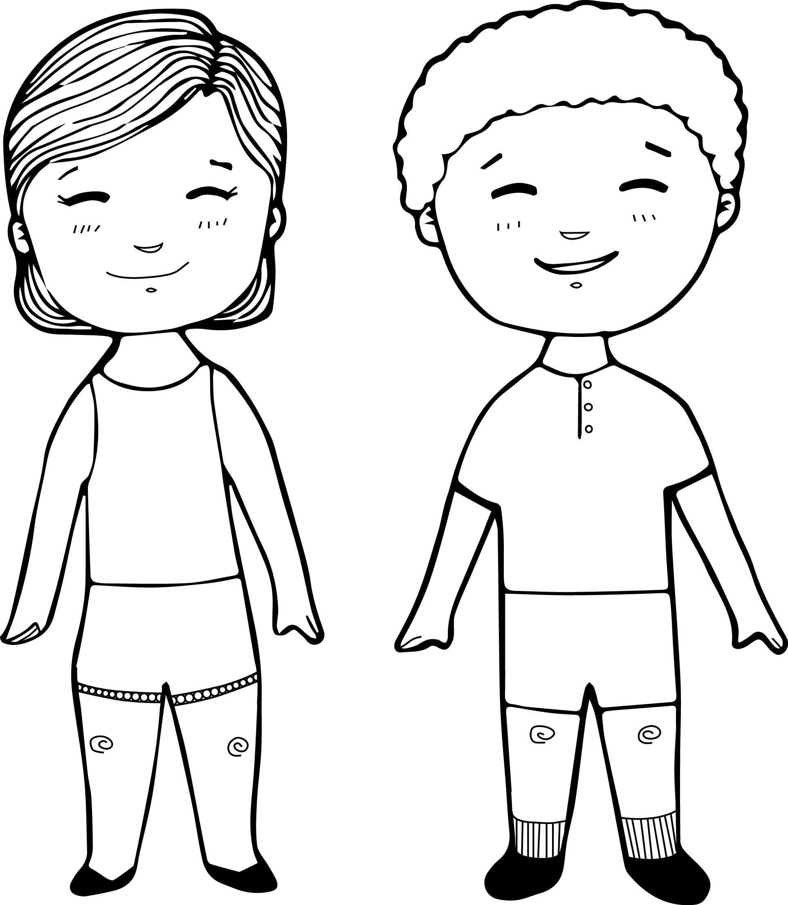

Join us for Storytimes/Wā Kōrero

(Time)am on (Day) at (Library)

Join us for Storytimes/Wā Kōrero

(Time)am on (Day) at (Library)

Join us for Storytimes/Wā Kōrero

(Time)am on (Day) at (Library)