TO: All Contractors
FROM: Rita Kirkland
DATE: February 17, 2021
SUBJECT: Proposal Addendum No. 6
RFP 21-002066
DATE ISSUED: January 14, 2021
THE PROJECT: St Louis Public Library – Wireless Implementation Project

- INTENT
This addendum is issued to provide a modification/addition to proposal plans and/or specifications.
- MODIFICATION / ADDITIONS

1. What is the current PoE budget for the switch infrastructure?
See attached PoE consumption chart.
2. How many outdoor access points per site is the library requesting be part of the proposal?
We are requesting the Bidder make a recommendation on the number of outdoor access points needed to cover the perimeter of the 5 Regional locations and parking lots of the 8 Neighborhood locations.
3. What license term is the library looking to see in this proposal per access point?
3 year
4. How high are the APs mounted in the buildings? Wall or ceiling? If ceiling, what type of material/construction?
We have a combination of wall-mounted and ceiling-mounted APs, as well as APs that are housed in furniture. The floorplans provided per Addendum 3 indicate if APs are not
located on the ceiling (except the floorplans for Central Library which do not indicate this). Ceiling mounted APs are attached to drop ceilings.

Page 2

5. Is existing indoor coverage/performance acceptable?
Yes.
6. Are there enough PoE switch ports to handle the addition of outdoor APs?
Yes.

7. How many SSIDs across all locations?
8
8. How do users authenticate today to the network?
There is no authentication on the guest network. All other SSID's use WPA2/PSK authentication. We are looking for best practices going forward.
9. Are there certain devices you want on the 2.4 vs 5?
We do have devices that require specifically 2.4 or 5.
10. For guest access, would you like a portal or splash page?
A splash page is preferred for guest access.
11. After numerous conversations with IT network engineers, technology manufacturers and low voltage experts, we suggest the St. Louis Public Library separate the bid of the exterior wireless portion of this project from the interior portion, ultimately, to allow all participants to complete an onsite survey of all sites for the most accurate proposal. We would suggest that the exterior portion of the project be a phase II to commence after the interior portion of the project is finished. Without physically being able to assess the wiring infrastructure needs, it would be very challenging for any partner to give any accurate assessment of the costs involved for these services. Once partners and low voltage experts are allowed to physically see the site, there will be a much more accurate estimated level of labor that is needed. Would the St. Louis Public Library agree with this logic.

No, but we can allow site visits if required.
Page 3

.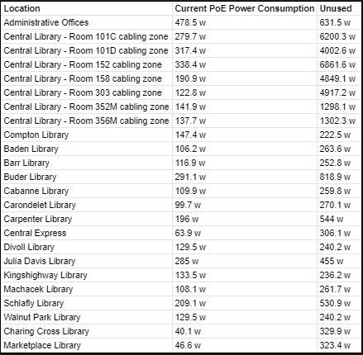

COMPANY: _____________________________________________

VENDOR’S SIGNATURE: _____________________________________________

TITLE: _____________________________________________

_____________________________________________
(Date)

