Social Story for Sensory Storytime at Central Library

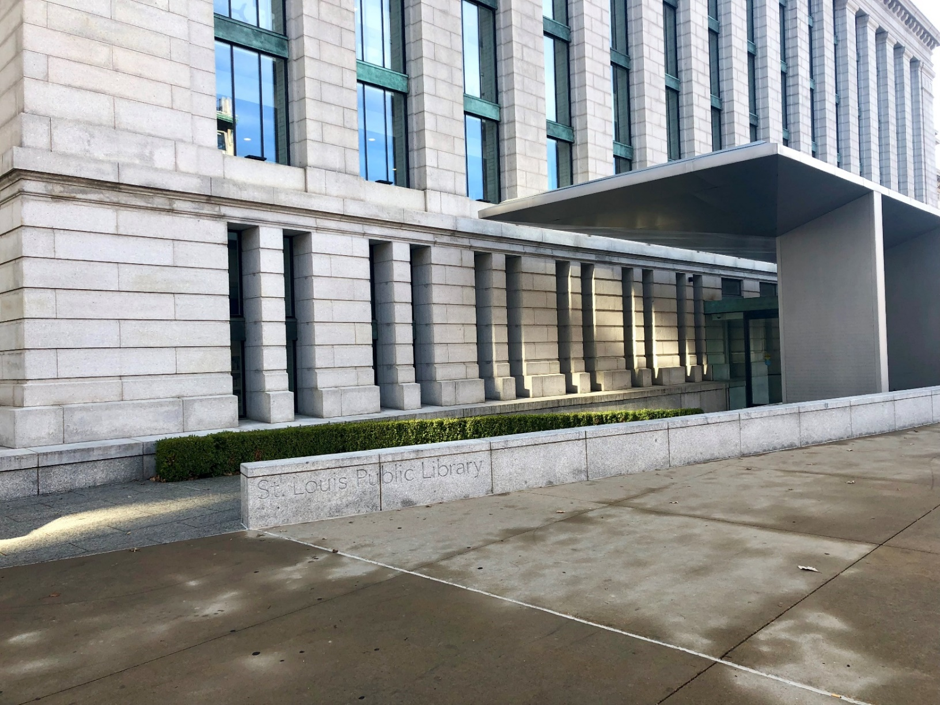
Today I am going to Storytime at Central Library.
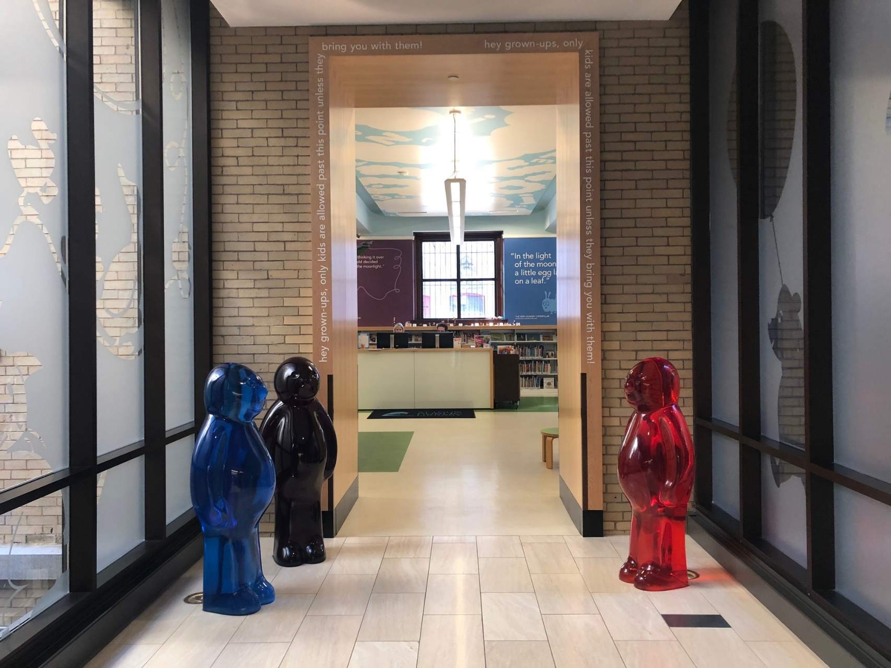
This is the Children’s Library Entrance.
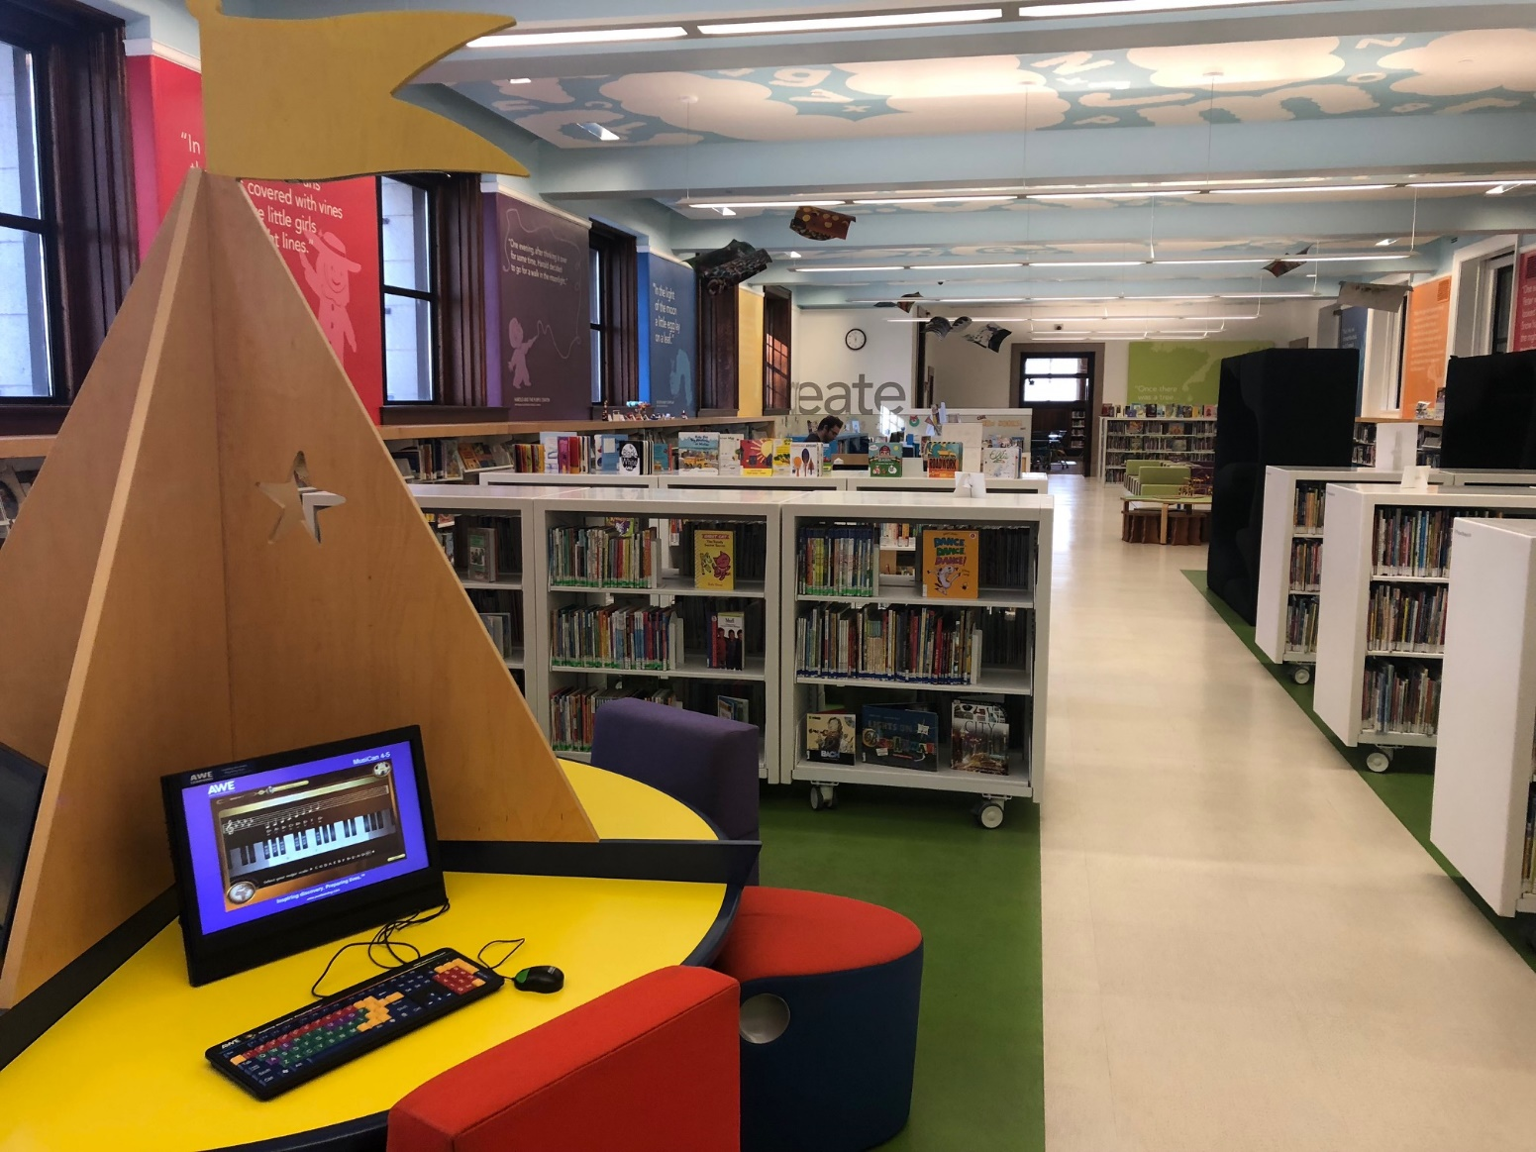
In the Children’s Library, I can read books, play games, or play on the AWE computers before or after Storytime.
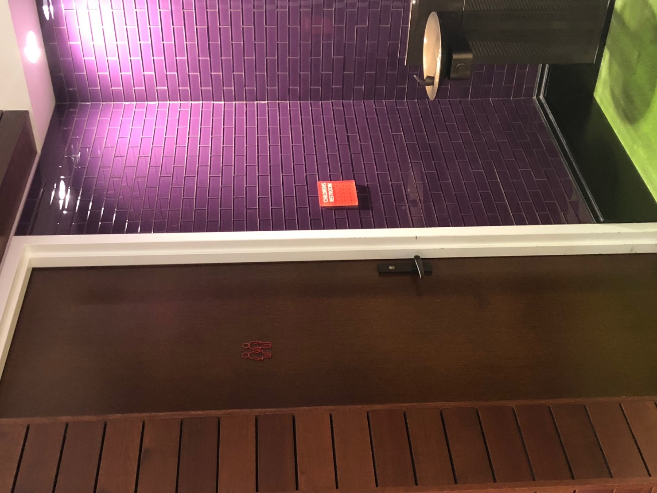
When I get thirsty, there is a water fountain where the purple tile is, and if I need to use the restroom, there is a special one just for me and my caregivers next to the water fountain.
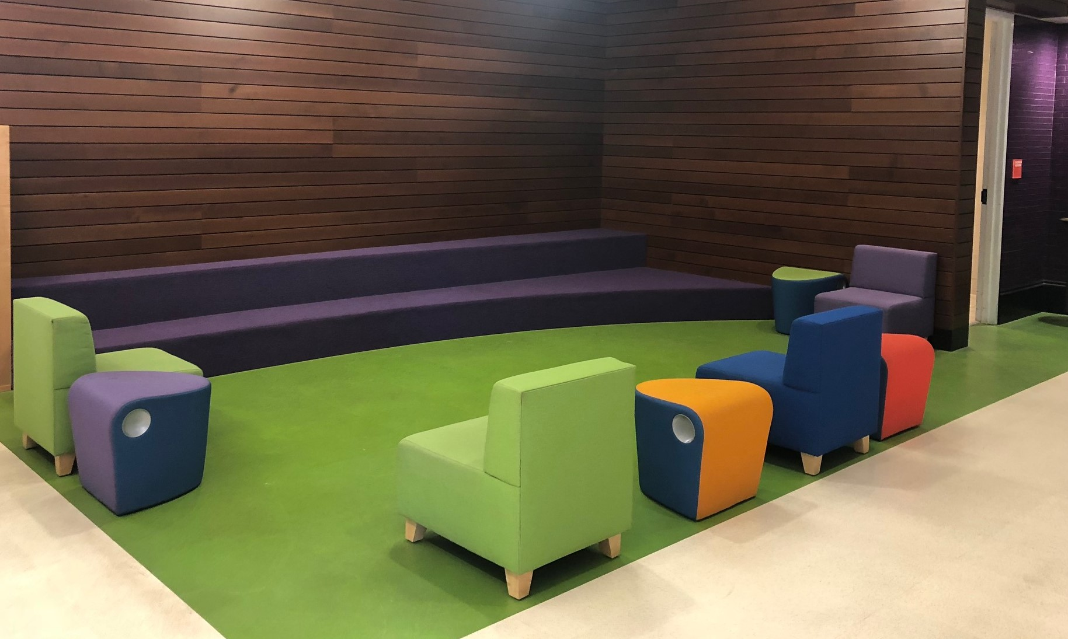
Just before Storytime begins, I go to the Storytelling Area.
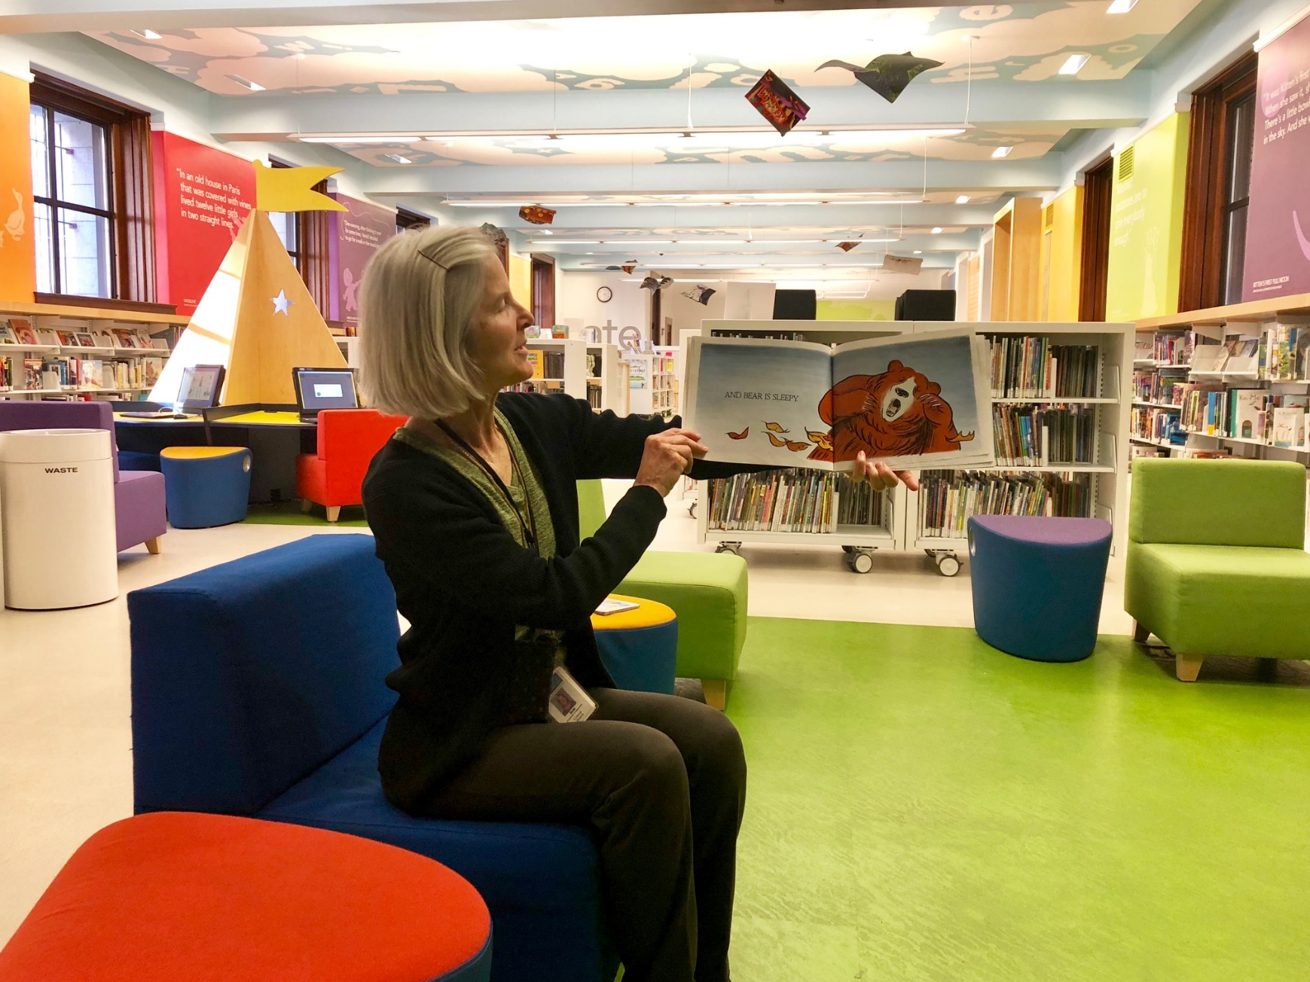
Miss Beth welcomes me and reads and tells stories to us.
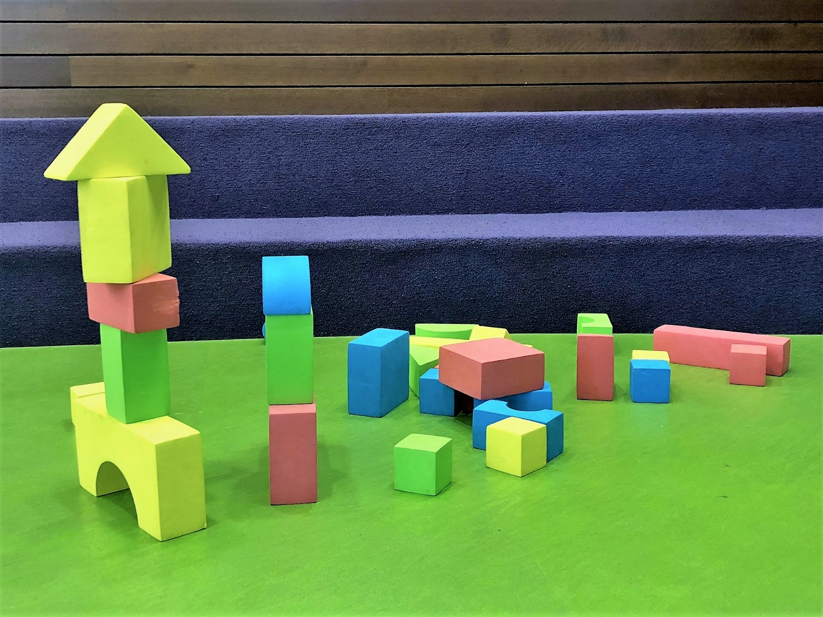
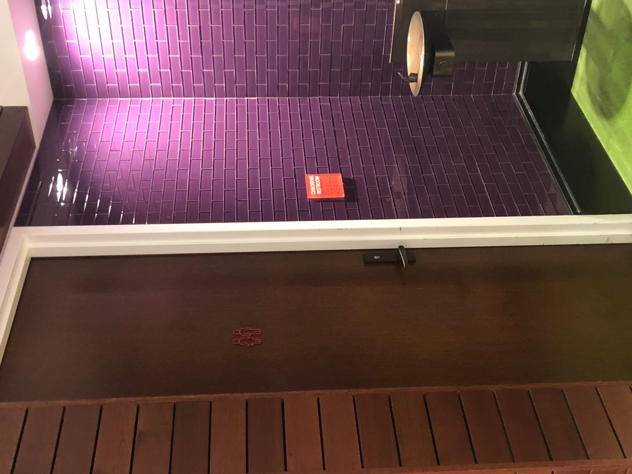
At the end of Storytime, I stay to play with toys and the other children.
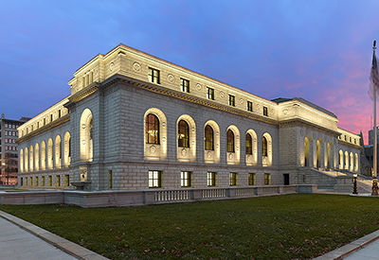
After Storytime is over, we all go home. I am not sad because I know I will come back for the next Storytime.

